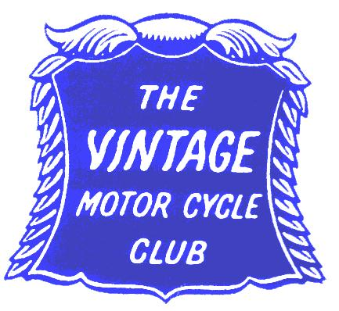

Clyde Valley Section
The VMCC Clyde Valley section invites you to join us on

The
‘Rock n Roll Run’ on Saturday, 23rd June 2018

A non-competitive social run primarily for motorcycles built in the 1950s and 1960s, but
open to all VMCC eligible machines.

Route:-
The main route will be approximately 130 miles, taking in Lanarkshire and Dumfries and Galloway with a stop for lunch at Leadhills.

** As an option there will also be a shorter route available for smaller capacity machines or those not wishing to go the full distance.

Venue :- Starting and finishing at The Oven at Overton Farm, Carluke ML8 5QF on the A72 Lanark Road between Rosebank and Crossford.

Start Time :- The run will be led off at 10.30am prompt.

Entries :- An entry fee, payable in advance, of £15.00 per machine and rider, with a reduced entry fee of £13.00 for passengers. Lunch is included in the entry fee.
Cheques should be made payable to VMCC Clyde Valley Section.
Open to members of the VMCC. Non-members may obtain a ‘free‘ one day membership

Closing date for entries :- 31st May 2018 or when list of entries is declared full

Accommodation :- There are a number of guest houses and hotels in the Clyde Valley area.

Contact :- Please return your completed entry form, remittance and declaration to

Willie Malone, 11 Castleview Road , Strathaven, Lanarkshire. ML10 6HD.

Tel.01357521375 Email:- williamgmalone@gmail.com

Clyde Valley Section
Entry Form

The ‘Rock n Roll Run’ on Saturday, 23rd June 2018

A non competitive social run primarily for motorcycles built in the 1950s and 1960s, but
open to all VMCC eligible machines.

Name:-………………………………………………………

VMCC Number (remember to bring your Membership card):-………………………………

Address………………………………………………….…………………………………….
…………………………….………………………………Post Code:-………………………

Email address:-………………………………………………………………………………….

Machine Make:-…………………………………………….Year:-………...
Model:-………………………………………………………………………
Capacity:-………………… Registration No...…………………………..
Passenger (if applicable):-………………………………………………………………………
History / background of your machine (optional):-………………………………………………………………………………………………….
………………………………………………………………………………………………….

Cheque enclosed:- Machine and Rider Entry fee. ……………………
VMCC day membership (if required) .……………………..
Total (payable to VMCC Clyde Valley Section)………………………

Adult Riders and Passengers
Entry Declaration
I/we, the signatories, apply to enter the event overleaf and in consideration thereof:-
1. I/we declare that I/we will comply with the requirements of the Highway Code and the instructions of the organisers and their officials insofar as they apply to the conduct of the event.
2. I/we further agree that I am/we are physically and mentally fit to take part in the event and am/are competent to do so.
3. I/we confirm that I/we understand the nature and type of the event and the risks inherent when entering and agree to accept the same notwithstanding that such risks may involve negligence on the part of the organisers/officials.
4. I/we further agree that I/we will not seek to claim against the Vintage Motor Cycle Club Ltd., the organisers or their officials, the landowners, the promoter or other bodies or individuals connected with the event in respect of any loss, damage, costs, claims or expenses that I have suffered or incurred, except for liability for death or personal injury arising out of the negligence of the Vintage Motor Cycle Club Ltd., the organisers, their officials, the landowners, the promoter or other bodies or individuals connected with the event. I/we further agree that the machine which I/we enter and ride/drive during the event shall be suitable and proper for its purpose, shall be insured as required by the Road Traffic Act or equivalent legislation and that it will comply with the regulations in respect thereof.
Minor (Under 18 years of age) Riders and Passengers and their Responsible Persons
Entry Declaration
We the undersigned apply to enter the event described overleaf and in consideration thereof both agree to the Declaration Parts 1,2,3 and 4 above and additionally :-
In consideration of the organisers allowing the Minor for whom I have declared responsibility to participate, I/we hereby agree and undertake to indemnify the Vintage Motor Cycle Club Ltd. And the Clyde Valley Section thereof, the organisers or their officials, the landowners, the promoter or other bodies or individuals connected with the event in respect of any claims made by the Minor for whom I have declared responsibility or any person on behalf of the Minor for whom I have declared responsibility for any liability, loss, damage, costs or expenses howsoever arising except for liability for death or personal injury arising out of the negligence of the Vintage Motor Cycle Club Ltd., the organisers or their officials, the landowners, the promoter or other bodies or individuals connected with the event.

Rider’s signature…………………………………………..

Passenger’s signature………………………………………

For riders and passengers under 18 years of age

I accept the above conditions of entry the this event and give my approval

Signature of person with parental responsibility………………………………………………

